Julian Boss, Jessica Kuelz, Bruce Shu, John Yun

**Key Audiences:** Consultants, Clients, Potential Clients

**Personas:**



**Name: Ken Smith**

Occupation: Consultant

Hobbies: skiing, boating, soccer, italian food

Ken is a consultant for Avanade who is onboarded on a couple of projects. While cutting it close when arriving to a meeting, he realizes that he needs a refresher on what specific services Avanade could provide for a particular business. Currently, his option is to call another team member or retrieve his project proposal



**Name: Dan Bush**

Occupation: Business Owner (Client)

Hobbies: Baseball, fishing, coffee, movies

Dan is a business owner who runs a warehouse fulfillment center. He is already a client with Avanade to update the current system into a more reliable & quick platform. Dan needs to find out information about his current service and what each option can do. Unfortunately, his consultant is unavailable and Dan needs to find this information to debrief his

managers in an upcoming meeting.



**Name: Jennifer Halloway**

Occupation: Small Business Owner (Potential Client)

Hobbies: Coffee, technology, music, wine, rock climbing

Jennifer owns a small technology store and is looking for some help with upgrading the store’s technology. She doesn’t know who to ask, so she’s been doing her research about different consulting firms. However, she wants to find more information before scheduling a

meeting to see if their mission aligns with her

business needs.

**Storyboards:**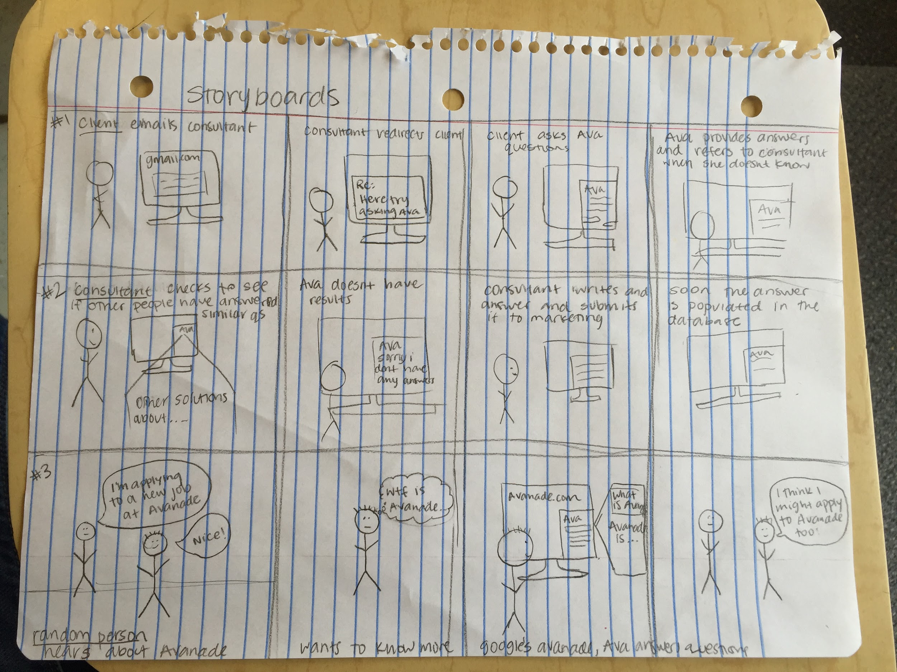

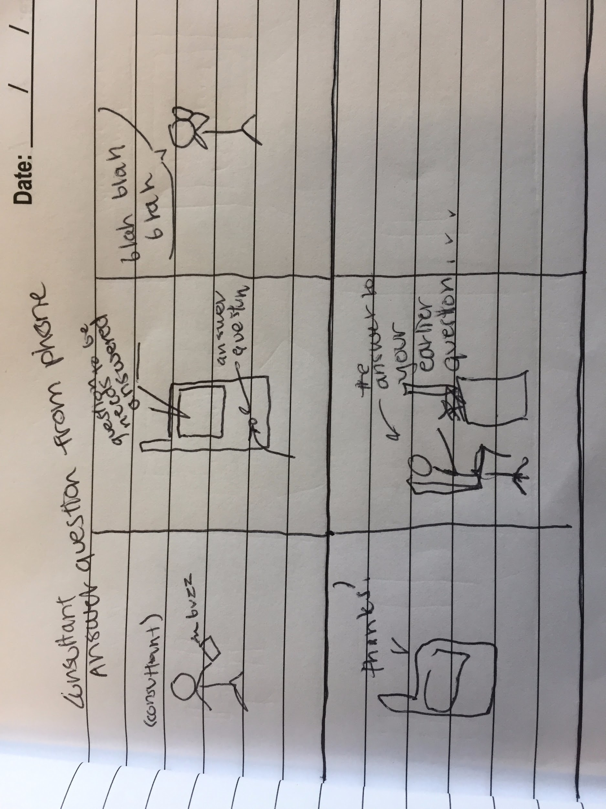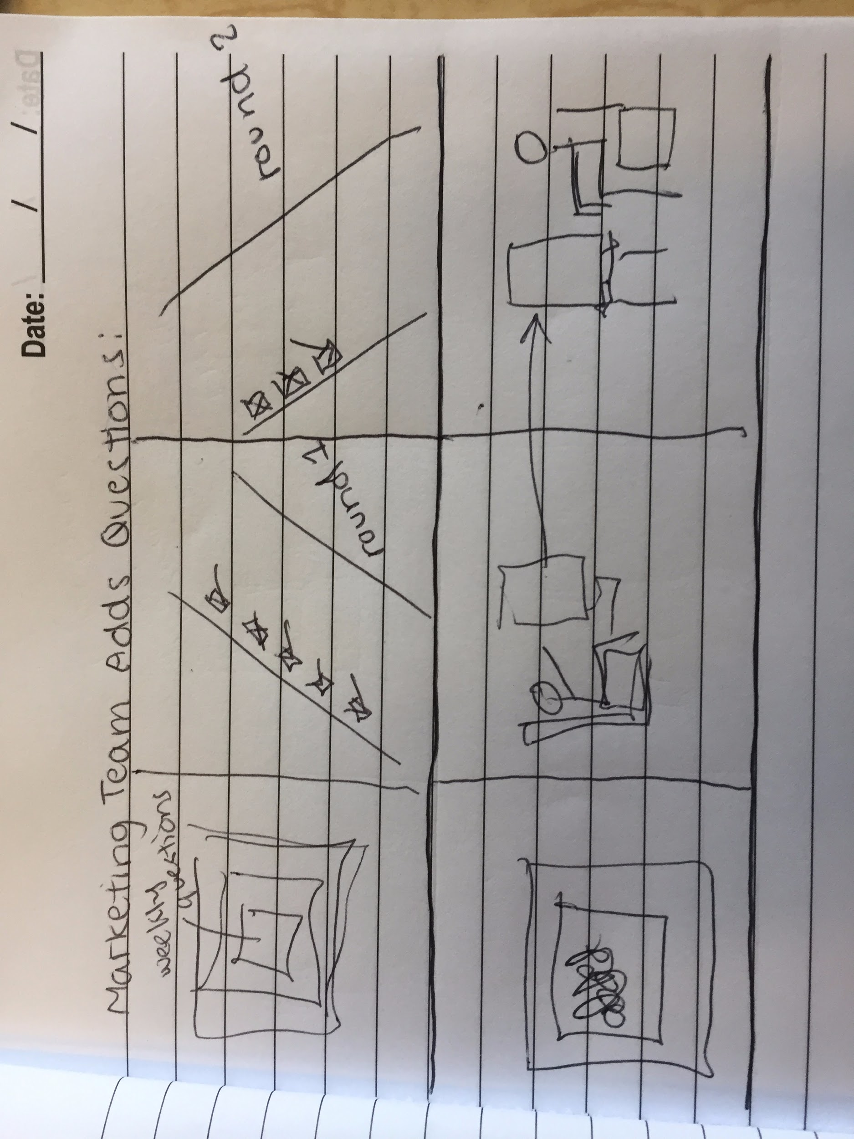o